**Aim**: Using Selenium.

**Objectives:**

* Record and run automated browser tests using Selenium IDE
* Modify test scripts for flexibility and accuracy
* Understand the test creation and execution process

**Tools Used**: Virtual box, Ubuntu , Selenium.

**Concepts:** Automation Testing, Selenium IDE, Script Recording and Editing, Test Execution

**Problem Statement:** To automate web application testing using Selenium IDE by recording user actions and modifying test scripts for better test coverage.

**process:**

**Creating Tests :**

1) Install the extension of the Selenium IDE in the firefox browser.

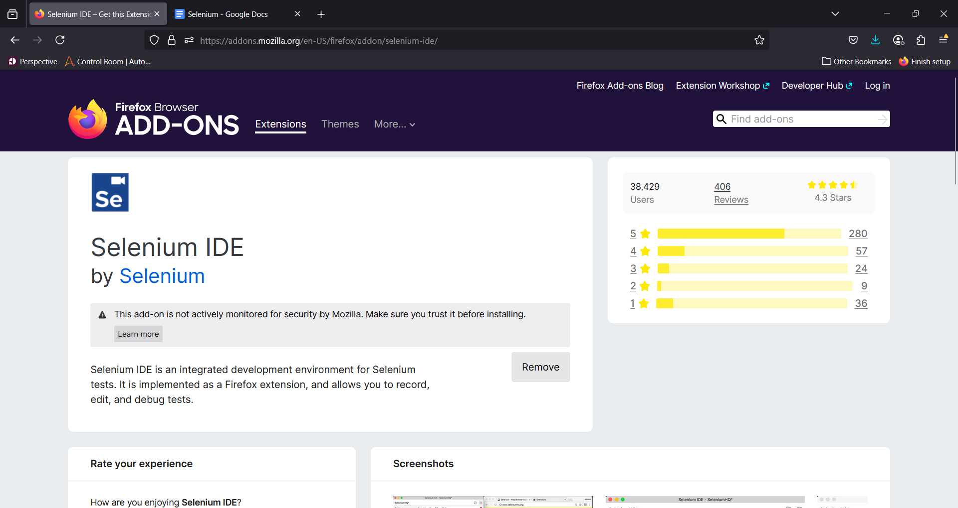2) Now run the extension. And then create a new project.

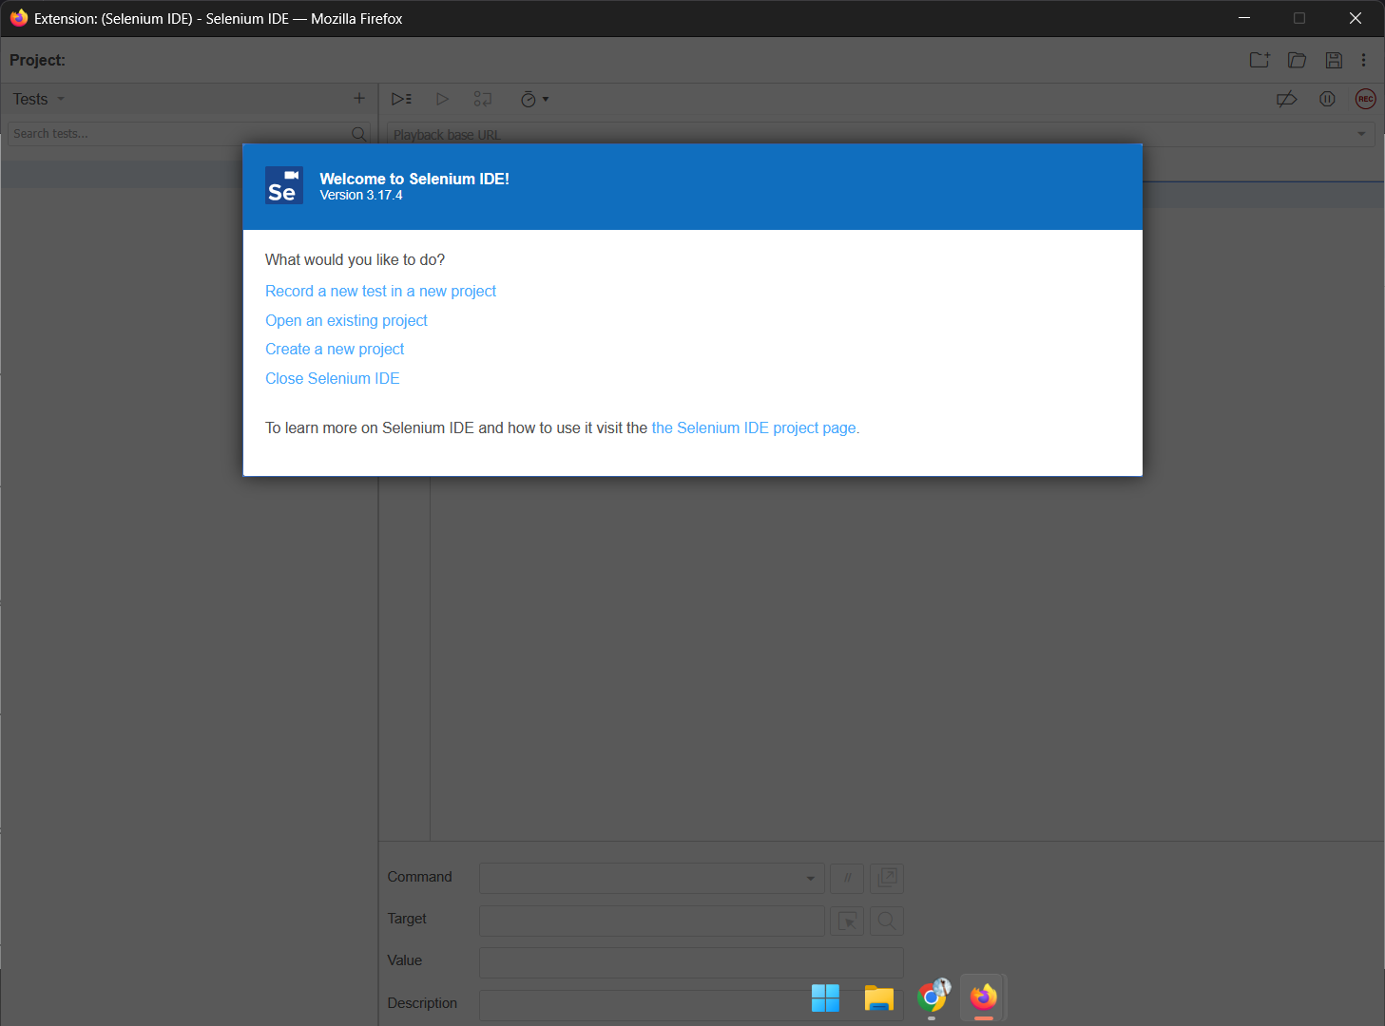

3) click on the REC btn in the top right corner. And start the process of the test, the selenium ide will automatically detect the event.

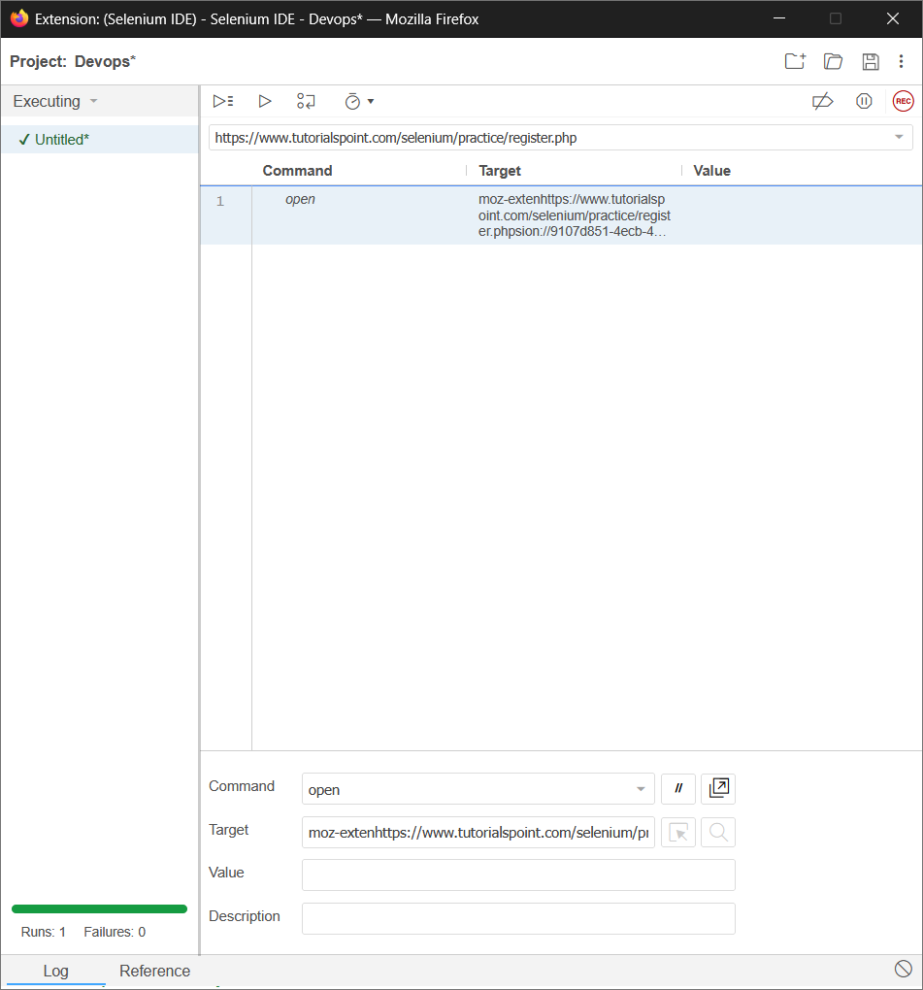

4) Now you will see all the steps that you have created and then just click on the the run current test.

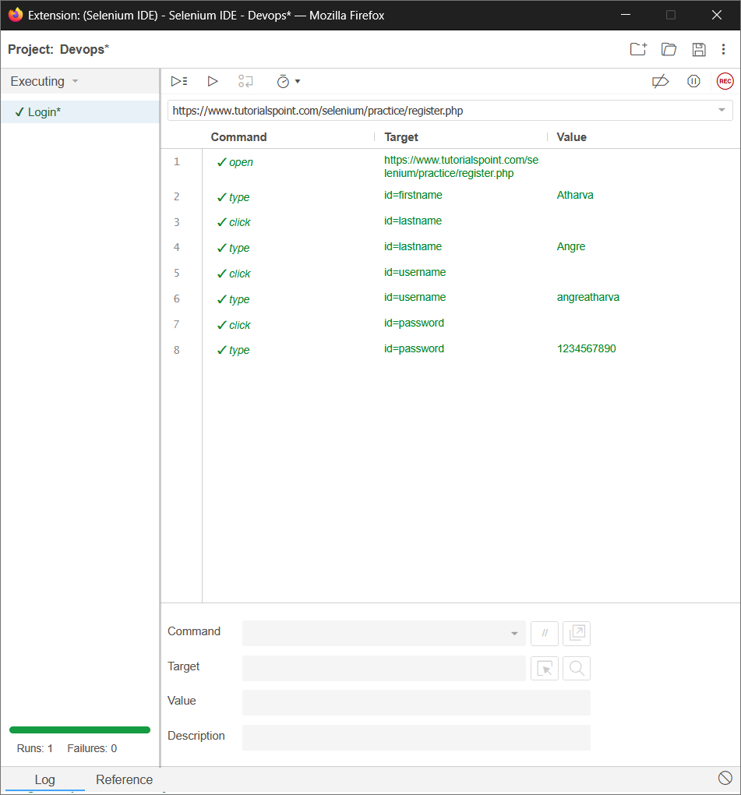

**Creating Script**

Create a new test as the same as above.  
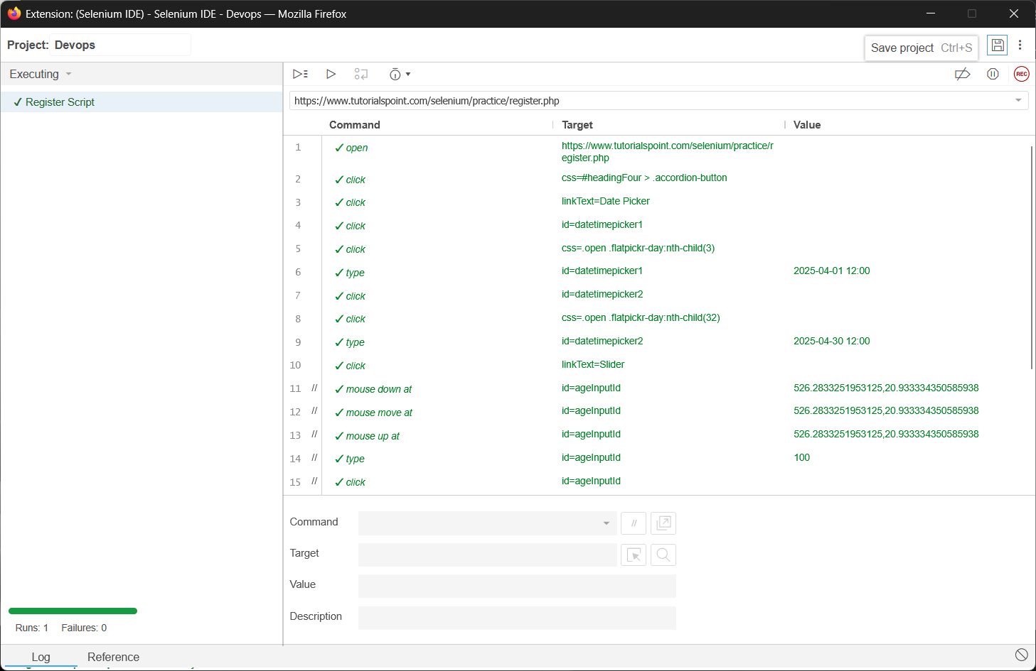

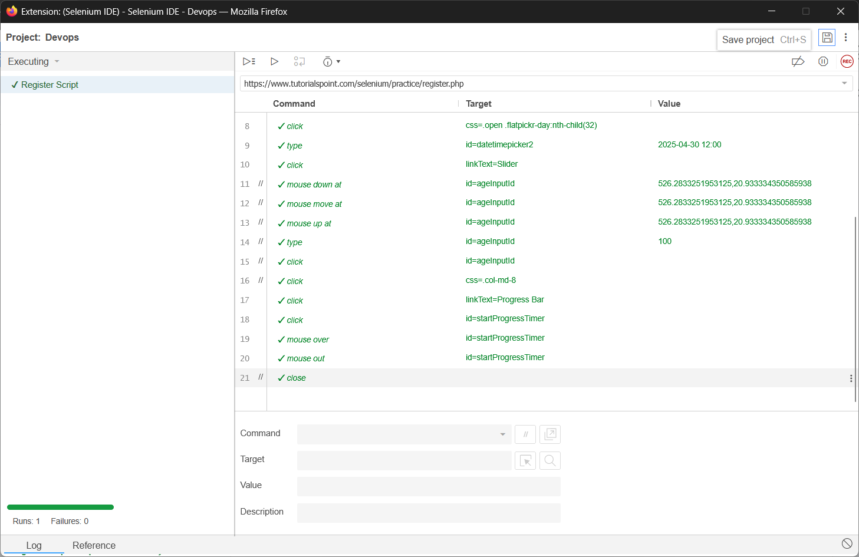

Here we made just a few changes like commenting some steps or changing some value.

**Conclusion:** Selenium IDE simplifies the process of automating browser tasks by recording user interactions and converting them into test scripts. It enables efficient testing with minimal coding, making it ideal for quick test creation and execution.